Topic
Name
Logo
Logo
Corresponding author email address.
Name of your institution
Conference Venue, Date, Venue
Poster Presentation Instructions
- Size and Orientation
  - Ensure that your poster is A0-sized (841 x 1189 mm or 33.1 x 46.8 inches). Refer to image at the end for reference.
  - The poster should be in portrait orientation.
- Design and Layout
  - Title: Use a font size that is large and easily readable from a distance (suggested: 72pt).
  - Headers: Use bold fonts for section headers such as "Introduction", "Methods", "Results", "Discussion", and "Conclusion": (suggested: 48pt)
  - Main Text: Text should be legible from at least a meter away (suggested: 24-28pt).
  - Captions: For images, charts, and tables, keep the font size slightly smaller than the main text but still readable (suggested: 24pt)
- Content Organization
  - Title at the top followed by the authors' names and affiliations.
  - Corresponding author email address.
  - Structure your poster with a clear flow.
    - Typical sections include:
      - Introduction
      - Objectives/Aims
      - Methods/process
      - Results /outcome
      - Conclusions and Recommendations
      - References (maximum of 3 relevant references)
- Visual Elements
  - Use high-quality images, graphs, and tables. Ensure they are clear and large enough to be seen from at least 1metre.
  - Avoid clutter. Keep enough white space to make the poster look organized and easy on the eyes. Align left/left justified (do not justify indentation).
  - Use color schemes that enhance readability and avoid those that clash or are too bright.
  - All photographic images must of persons in the study include consent
  - Font: Stick to one or two font types to maintain consistency e.g. consider Arial and Helvetica fonts
  - Use bullets, numbering, and boxes to organize and highlight important information.
  - Ensure your content is concise. A poster should be a visual summary of your research, not an exhaustive explanation
- Material & Mounting
  - Print on high-quality, matte-finish paper to reduce glare
  - Use mounting materials provided at the presentation venue
  - Ensure the poster sits flat and securely on the board.
- Presenting
  - Familiarize yourself with poster presentation timings
  - Stand to the side of your poster so viewers can see it without obstruction.
  - Prepare a 2-3-minute summary of your work for interested attendees.
  - Engage with viewers, answer questions, and seek feedback.
- Extras
  - Consider having handouts or business cards available for interested attendees.
  - A QR code linking to your full paper or additional resources can be a modern and efficient touch.
- Safety
  - Ensure no protruding elements, sharp edges, or loose pieces that can be hazardous to conference participants.
- After Presentation
  - Make sure to take down your poster at the designated time

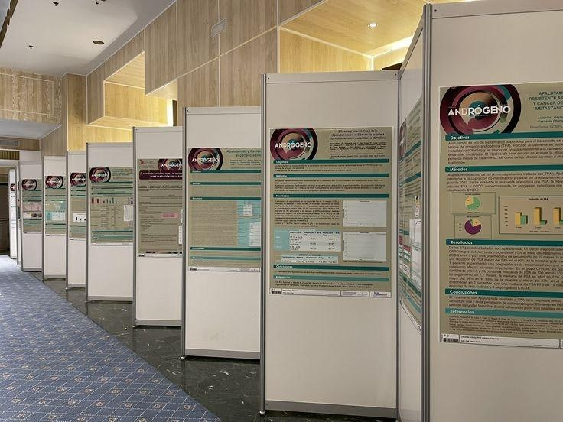
Sample of suitable poster.

